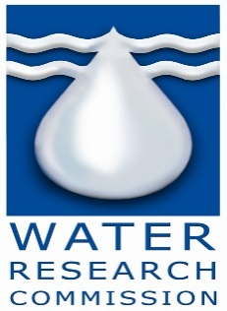

INVITATION TO BID

WATER RESEARCH COMMISSION INVITES SUITABLY QUALIFIED AND EXPERIENCED SUPPLIERS TO SUBMIT PROPOSALS FOR THE FOLLOWING BID/QUOTATIONS.

WRC was established in terms of the Water Research Act (Act No 34 of 1971), following a period of serious water shortage. It was deemed to be of national importance to generate new knowledge and to promote the country’s water research purposefully, owing to the view held that water would be one of South Africa’s most limiting factors in the 21st century. In 1971 when the WRC was founded, water research and development (R&D) in South Africa was limited to a few institutions and the funding level inadequate. There was no research co-ordination and an apparent neglect of some key research fields. In addition, there was little strategic direction or leadership that would provide for the identification of priority areas or appropriate technology transfer. It was to address these issues, that the WRC was established.

B

Bid documents of the following bids can be downloaded from WRC website: www.wrc.org.za

Bid No.: | Bid Description | Bid Submission & Briefing session Address | Compulsory Briefing Session | Closing Date  &  Time
WRC-010-18/19 | Appointment of a service provider for the supply and delivery of building materials to 11 sections in Tshakhuma village, Vhembe District | Tender Box  Bloukrans Building  Lynnwood bridge Office Park;  Second Floor;  4 Daventry Street; Lynnwood Manor; Pretoria | N/A | 13 August 2018  at 11:00 am
These bids are issued in accordance with the Preferential Procurement Regulations 2017. WRC is not obliged to accept the lowest or any bid.

Completed sealed bid documents, clearly marked with the specific bid number must be submitted at the above-mentioned addresses, no later than the closing date as stipulated above. (1) Original bid document and (1) copy of bid document must be submitted.

No late bids will be accepted. WRC supports Broad-Based Black Economic Empowerment. For more information, please contact The SCM Manager on the following number: Tel: (012) 761 9300 or e-mail: tenders@wrc.org.za

