**Innovative Sanitation/Greywater Technology Scan Questionnaire**

**1. Name of Company/Organization**

|  |
| --- |
|  |

**2. Overview**

Please a concise description of the technology. Also discuss the innovativeness of the technology and how it will contribute to achieving the objectives of SASTEP **(*400 words max…)***

**3. Previous demonstrations/Implementations**

Provide a brief description of any previous demonstrations and or technology implementations conducted in public or private facilities and include their results. You can focus on the following: number of units installed; performance metrics; location of technology demonstration or implementation; scale of demonstration or implementation; partners involved, performance outputs

**4. Company Information**

|  |  |
| --- | --- |
| Has the technology been tested independently? |  |
| Can the technology be categorized as Non-Sewered Sanitation or Greywater System? |  |
| State which settlement type(s) is your technology fit for (household, communal and commercial buildings, rural, peri-urban, informal, and urban settlement types) |  |
| If sanitation technology is proposed, does it conform to the ISO 30500 ? |  |

Please provide proof of field test results and certificates

**5. Legal and Intellectual Property**

What IP protection do you currently have for this technology? (Tick one)

|  |  |  |  |  |  |
| --- | --- | --- | --- | --- | --- |
| Not protected |  | Design application filed |  | Registered trademark |  |
| Patent application filed |  | Registered design |  | Trade secret |  |
| Patent granted |  | Trademark application filed |  | copyright |  |

|  |  |
| --- | --- |
| Are there partnerships or benefit sharing agreements required/in place? |  |
| Are non-dsiclosure agreements required/in place? |  |

Please provide additional information (e.g scope of protection, patent number, registration number etc…) ***(150 words max..)***

**6. Legal and Intellectual Property**

Please provide brief description of the value proposition, market potential and market segments relevant for this technology ***(200 words max…)***

**7. Technology Readiness Level (TRL)**

|  |
| --- |
|  |

Please indicate the TRL of the technology

Definition of TRL levels

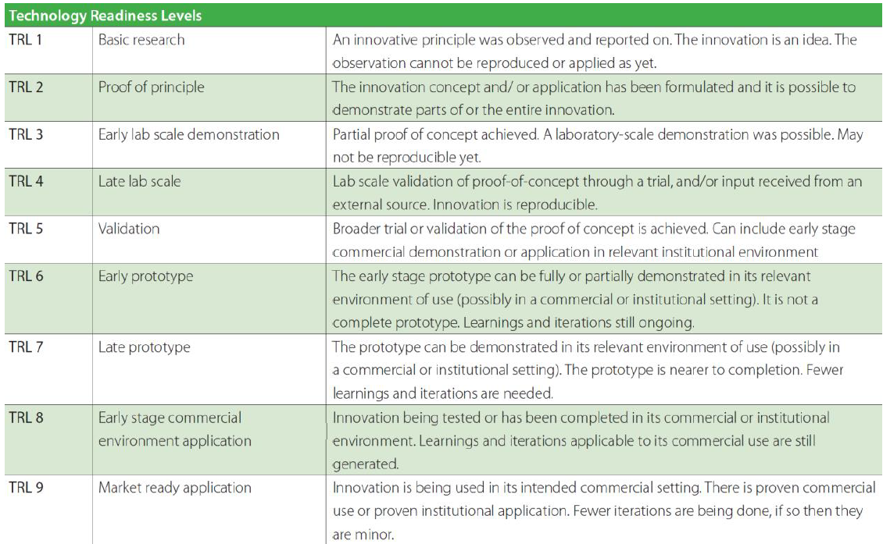

**8. Business opportunity**

Please indicate what business opportunity(ies) that you are seeking for this technology?

|  |  |
| --- | --- |
| Technology licensee opportunity |  |
| Investment |  |
| Entrepreneur |  |
| Technology development partner |  |
| Business development partner |  |
| Manufacturers |  |
| Other (please specify) |  |

**9. Contact Details**

|  |  |
| --- | --- |
| Title: |  |
| First name: |  |
| Middle names: |  |
| Surname: |  |
| Address 1: |  |
| Address 2: |  |
| City/Town: |  |
| Province: |  |
| Postal code: |  |
| Work Telephone: |  |
| Cell: |  |
| Email: |  |

**10. Previous experience in technology localisation**

Has your company locally manufactured (from prototype to large scale production) a local or international technology with market uptake? If so provide more details ***(300 words max…)***

**11. Additional information**

Please provide additional information (if any) to support your application ***(300 words max…)***