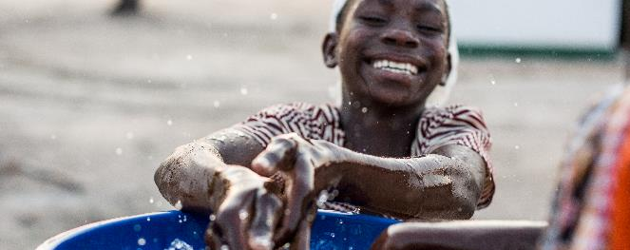

**Xabisa Indalo for Water:**

**Learning to invest in ecological infrastructure for water security**

The importance of managing ecosystems to enhance downstream water quality, quantity and built infrastructure maintenance benefits is increasingly recognized internationally. The Water Research Commission is leading the Social Learning and Knowledge Component of the Global Environment Facility (GEF) funded Ecological Infrastructure for Water Security project, through the South African National Biodiversity Institute (SANBI) and the Development Bank of South Africa (DBSA). The project aims to unlock development finance and secure ecological infrastructure for water security in critical water catchments in South Africa.

The Water Research Commission is responsible for facilitating knowledge management and social learning so as to change the way targeted public and private sector stakeholders and decision-makers engage with, think about and integrate ecological infrastructure into water sector development planning and finance. The WRC has contracted Rhodes University to develop a “Participatory course to activate Ecological Infrastructure for Water Security Learning Networks”, which is referred here as *Xabisa Indalo for Water*. The course aims to support EI4WS Change Projects in order to strengthen social learning and knowledge mediation around EI4WS financing, policy, planning and development. Xabisa means "to value" and Indalo means "nature" so the phrase means "Value Nature for Water". Knowledge resources and further information are available below.

**Xabisa Indalo for Water Course**

**Open Access Training materials**

**Future access for course participants and trainers under development**

**Knowledge Hub**

**Case studies**

**News and Upcoming Events**

**Infographics**

**Technical reports**

**Useful Links**

**Water Pricing Course Open Access Training materials**

**Contact us**

Michelle Hiestermann

Senior Knowledge Coordinator

Water Research Commission

[michelleh@wrc.org.za](mailto:michelleh@wrc.org.za)

Dr. Roderick Juba

Researcher

Water Research Commission

[roderickj@wrc.org.za](mailto:roderickj@wrc.org.za)